Join Manalapan’s

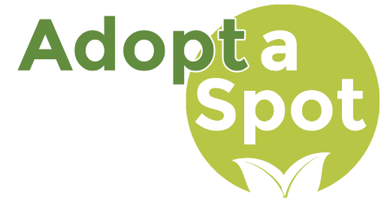

Adopt-A-Spot/Road

Volunteer Program Today!

Help Keep Manalapan

Beautiful, Clean, and Safe!

**For an Application & Additional Information visit**

**www.mtnj.org**

Gloves, bags, vests, supplied by NJ Clean Community Grant!

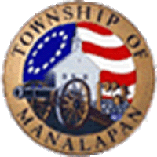

The Adopt-A-Spot/Road Volunteer Program allows passionate citizens to make a change in their communities. Through this program, Manalapan residents and groups will have the opportunity to “adopt” a public spot or road around town and pledge to make at least (2) cleanups per year.