Vietnam Veterans of America Chapter 12 - Fishing Programs
“Playing Hooky from PTSD”
By Greg Kucharewski
The Vietnam Veterans of America Chapter 12 (VVA 12) fishing program has been supported by VVA Chapter 12 and Veterans of Foreign Wars Post 2226 for 2 ½ years. Approximately, $1,800.00 in various door prizes to include rods and reels was donated to our veterans through the generosity of supporters of the program. With the help of VVA Chapter 12 members and local fishing club volunteers we conduct monthly surf fishing clinics and a variety of fishing workshops for veterans that experience Post Traumatic Stress Disorder (PTSD) and Traumatic Brain Injury (TBI). Our goal is to help veteran men and women take time to heal by utilizing healthy outdoor activities, such as fishing and outdoor events. We also connect veterans to VA Service Offices, Outreach Centers, NJ Coastal Parks, Fishing Clubs, and Veteran Organizations.
Ninety-five percent of combat veterans that attend the fishing workshops have PTSD. They suffer from sleepless nights, flashbacks, anxiety, addiction and a range of other issues that impair their quality of life. Several of the combat veterans waited years to receive help and are now working to improve their mental health by seeking assistance from the VA. Most veterans realize it is a slow process but the first step is to send their claim in for processing. As veteran’s age, PTSD symptoms become worse, many men and women have suffered in silent isolation for most of their life. The time is now to submit a claim before declining health issues make it difficult to collect evidence for a claim. As in the case of my neighbor who is 91 and fought in Germany at the Battle of the Bulge. His claim is caught in a back-log of paperwork for review and I am sure he won’t receive benefits in his lifetime.
Each fishing workshop begins by explaining how our Chapter 12 members can relate to what our younger veterans are going through. Ex-military are very sympathetic and supportive to our younger veterans. At the end of the fishing workshop you can find Don Davidson, Retired First Sergeant, United States Army, speaking to younger veterans and suggesting they visit a Veteran Service Officer (VSO.) Don has a get er done attitude and connects veterans with VSO’s and others that can help veterans pronto. We do not want our younger veterans waiting years for treatment so we encourage them to visit a VSO as soon as possible and phone often to check on their claim.
Warfighters connect with warfighters! Veterans connect with one another and understand certain feelings and emotions that civilians tend to blow off or look at as a scam. I find it difficult to believe that veterans suffering with PTSD are questioned about the legitimacy of their illness. It’s hard to make something right when the majority of people are not educated about combat survivor guilt, flashbacks, and trauma arousal triggers. Finally, after 40 some years we are seeing public service announcements on TV about PTSD and featuring patients that talk about their invisible wounds. Guess what folks? It’s real, just like Agent Orange. Stuff like not getting the word out to our veterans in a timely manner makes my blood boil. I’m proud to be a member of Chapter 12 they get all kinds of information to their members fast.
PTSD also affects families because family members do not understand what the veteran is experiencing. Professional family counselling is needed as well. The VA is making more progress in this area for families and work to keep families as functional as possible.
Members of Chapter 12 spend time listening and trying to engage veterans in a healthy outdoor activities and volunteering. We know the fishing program is working because veterans welcome the chance to learn about the benefits of spending time on the water and fun outdoor activities. Our Chapter 12 fishing program doesn’t solve all health problems but gives veterans an opportunity to forget about the horrors of war and makes them feel better. It’s like what I like to call “Playing Hooky” from PTSD. “Playing Hooky” from PTSD helps relieve symptoms by taking the focus off unpleasant thoughts and replacing them with present moment positive thoughts.
We are expanding our fishing programs to include veteran family members. Spouse/significant other, kids, grandchildren/parents or your fishing buddy all are welcome to attend these events. Just recently, we conducted a “Cast a Line of Caring for Veterans” where we displayed a learning booth for children attending the Monmouth County Armed Forces Day Open House. Military vehicles, Chapter 12’s Vietnam booth/Color Guard, emergency equipment, and veteran help agencies were on display along with a working dog and therapy dogs for veterans. Youngsters had a chance to test their casting skills by casting and reeling in a plastic fish targets to win small patriotic prizes. Members from Vietnam Veterans Chapter 12 and Jersey Coast Anglers Association's Youth Education Committee had plenty of information for veterans about local fishing clubs, NJ DEP/Parks Fishing Access, Veteran Outreach/Services and upcoming events to connect veterans with the outdoors.
If you would like to be part of this, please phone Greg @ 732-785-9278 or email gkucharews@jcaa.org Our next program will be in June or July depending on interest and hall availability.
For veterans with physical health issues and trouble navigating in sand we have 15 new beach wheelchairs available at Island Beach State Park, for fishing and enjoying a day at the beach. Phone the park for details 732-793-0506. Don’t forget to apply for a FREE Fishing & Hunting License for Service Connected Veterans and NJ State Park Passes for Qualified Veterans or a free Park pass if you are over 62 years old.
This year I am making it a point to fish with LT (Bob Hopkins.) Hopefully, LT will share some of his early morning Striped Bass secrets. We miss our good fishing friend Jim Monahan AKA (Big Tuna) who always fished every chance he got and had the biggest smile while fishing. Jim fished even during work hours at Fort Monmouth and helped with the kids fishing program on his lunch hour. I still can’t figure out how he did it but I know he worked long hours.
Other fun things to do as a family include: Discounts for Lakewood BlueClaws Games, Home Runs for Heroes, DEP Fish & Wildlife/Parks Outdoor Events, Car Shows for Veterans (Sponsored By VVA Chapter 12) 10/2015, Family Fishing Fluke Tournaments, Governor’s Surf Fishing Tournament, FREE Veteran Fishing Seminars, Operation Horse, New Jersey Veteran Charter Boat and Kayak Trips, Chariot Rider Horses for Heroes, Run For The Warriors Events, Shark Fishing Tournament for Wounded Warriors, Honor & Courage “Wounded Warrior Run, Roll & Stroll 5K, NJ Veteran Golf Outings, Fishing Events for Veterans, FREE Hunter Education Programs, America’s Disabled Veteran’s Outings (NJBBA/Elks, VFW, & Others), Veteran Service Organizations that Sponsor Events, NJ Heroes On the Water, Project Healing Waters, Membership Opportunities for Fishing & Hunting Organizations, and New Jersey Disabled Access Locations Near You. If you would like to learn more about the above phone 732-785-9278.

Special thanks to our friends that donated to the Veteran Fishing Program.
VFW Post 2226, Home Depot (thanks John), The Fisherman Magazine, One More Cast Rigs, Pell's Fish & Sport, Atlantic Bait & Tackle, Jersey Coast Anglers Association, The Kayak Store, Butch and Pat Pawson Tackle, Don Marantz, Joe’s Used Tackle, Fisherman’s Den, New Jersey Beach Buggy Association, Brielle Bait and Tackle, Reel Life Bait and Tackle, New Jersey Outdoor Alliance, Bob Benkovich, Captain Kevin Pinto, Jonny Marlin and private donations from family/friends.

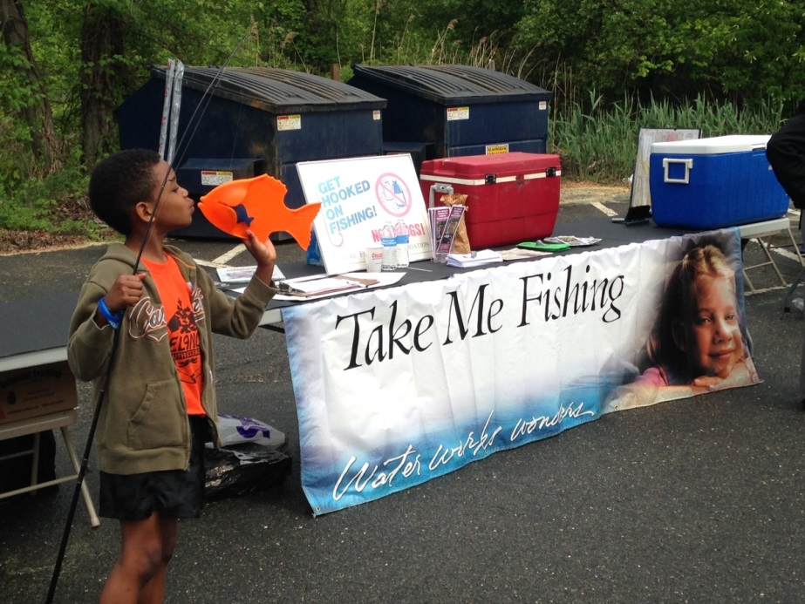
Armed Forces Day Cast a Line of Caring for Veterans
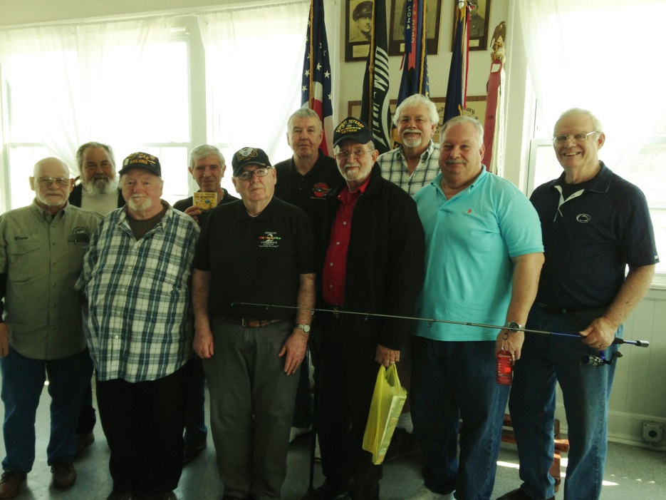
Prize winners at the April, Flounder Fishing workshop.
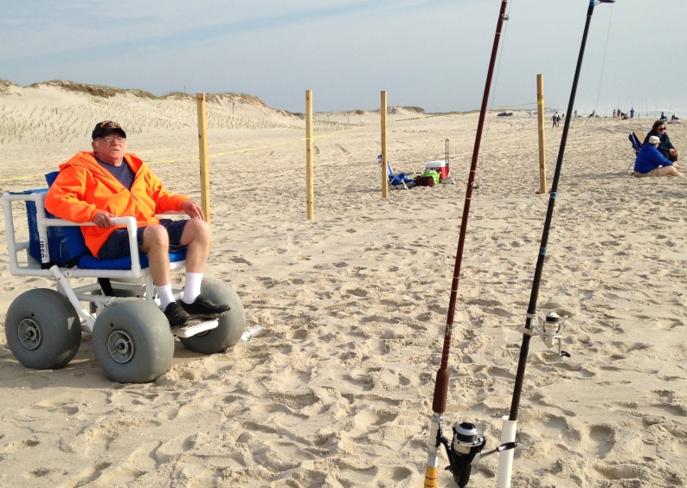
Vietnam Veteran fishing in one of the new beach wheelchairs at the Island Beach State Park

