PTSD AWARENESS

When service members return from a war zone, they all breathe a sigh of relief. Their first thought is, "It's over, I'm home, and I'm safe!" But for many, the war is never over - the memories, the sounds, the images, and the smells never go away. It's hard to imagine that anyone that has been wounded in combat and lived to tell about it, doesn't suffer from some form of post-traumatic stress (PTS)." Long after they leave the battlefield, some veterans continue to battle with invisible wounds that can be just as debilitating as the physical scars of combat. The problem is that these wounds are much more difficult to recognize and treat. It's possible to have undiagnosed PTS for 30 years and not realize it -- possibly never, or until you find a way to get better and then you realize there is another way to live.
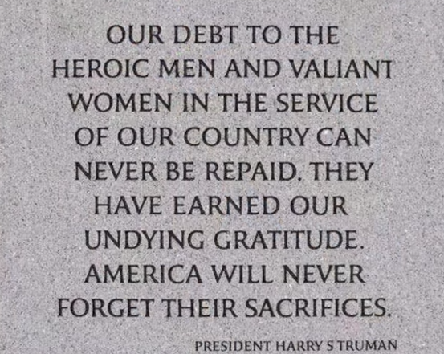

Post-Traumatic Stress is not a new phenomenon, it just has a new name. In WWI it was called Shell Shock; in WWII it was Combat Fatigue and then Combat Stress Reaction. After the Korean and Vietnam Wars, it was called Post Traumatic Stress Disorder. More recently, however, the word "disorder" has been downplayed to help remove the stigma of the illness. PTS is not unique to military personnel; it can result from any trauma or life-threatening event, no matter where it takes place. The symptoms of PTS may include upsetting memories or dreams of an event, increased jumpiness, depression, anxiety, or trouble sleeping. In extreme cases it can even lead to suicide. For those suffering from PTS, it can affect all aspects of a veteran's life, often taking family and friends as extended casualties of this silent, invisible war.


The first step in combating PTS is to raise awareness about this crucial issue, recognizing the symptoms in yourself or others, and knowing where to look for treatment. June 27 has been designated by VA as PTS Awareness Day for the fourth consecutive year. "Raising PTS awareness is essential to overcoming the myth, misinformation and stigma that too often prevents Veterans from seeking help," said VA Secretary Robert A. McDonald. The VA is one of the largest integrated mental health systems in the United States that provides specialized treatment for PTS, and the numbers are alarming. As of September 2014, there were about 2.7 million American veterans of the Iraq and Afghanistan wars, compared to 2.6 million Vietnam veterans. In fiscal year 2014 alone, more than 535,000 of the nearly 6 million Veterans who sought care at VA healthcare facilities received treatment for PTS.
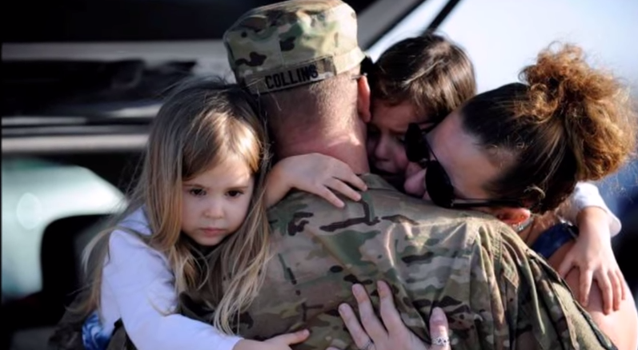

From October 1, 2001, to December 31, 2014, nearly 400,000 Post-9/11 Veterans were seen for potential PTS at VA facilities following their return from overseas deployments. By comparison, a Vietnam Veterans' Readjustment Study done in the 1980's initially found that "for Vietnam theater veterans, 15% of men had PTSD at the time of the study and 30% of men had PTSD at some point in their life." But a 2003 re-analysis found that "a large majority of Vietnam Veterans struggled with chronic PTSD symptoms, with four out of five reporting recent symptoms when interviewed 20-25 years after Vietnam." Even given these numbers, it is estimated that 50% of those with PTSD do not seek treatment.
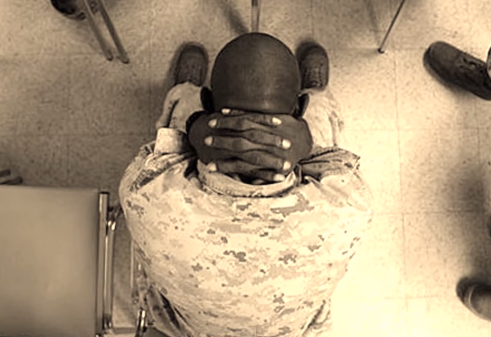

All Patriots are encouraged to be vigilant, both inward and outward; to watch our own thoughts, just as we are observant of the words and actions of our brothers and sisters for signs of PTS; to be open and honest with ourselves and each other about the scope of the issue and its effects on us and our families. For more information on PTSD and the ways to raise awareness, please visit the VA's National Center for PTSD website.



