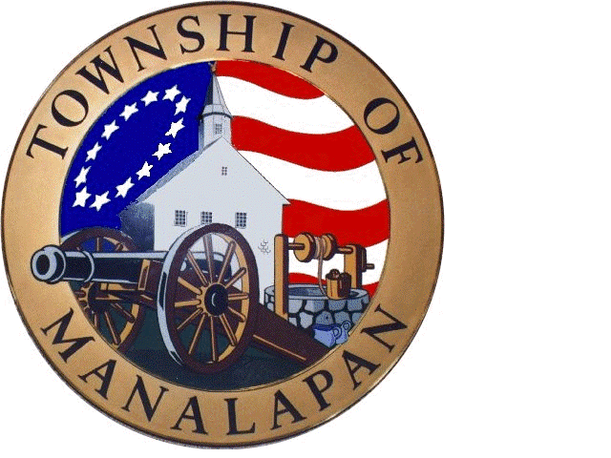

MANALAPAN DAY 2015
SPONSORSHIP APPLICATION

Platinum Sponsor = $3000 or more
  - You provide us with your banner and we will proudly display it in the Main Stage area or we will make one for you.
  - Exhibit Space to promote your company, if desired.
  - Announcements of your sponsorship by our MC from Main Stage.
  - Placement in our Publicity Ads and signage as a Platinum Sponsor.
  - Placement on our signage as a Platinum Sponsor.
  - Placement of your banner at Manalapan Arts Council Concert Series.

Gold Sponsor = $1000 Each
  - You provide us with your banner and we will proudly display it. (Maximum banner size 8’long by 3’ high with grommets).
  - Exhibit Space to promote your company, if desired.
  - Placement in Publicity Ads and signage as a Gold Sponsor.

Silver Sponsor / Future Stars Stage = $500
  - You provide us with your banner and we will display it by the Future Stars Stage.
  - Exhibit space (18’ X 18) in the vendor area.
  - Placement in our Publicity Ads and signage as a Silver Sponsor.

(Please list the Name exactly as it should appear in publicity ads)

Business Name: Name to be used for advertising, different:

Address:

Phone Number: Contact Person: E-Mail Address Platinum/Gold Sponsors- would you like Exhibit Space? ( ) YES or ( ) NO.
Silver Sponsors – 18’ x 18’ Vendor Space in vendor area? ( ) YES or ( ) NO.

Please make sure your check & form are mailed to the address listed below by May 29th .
Applications received after this date cannot be guaranteed placement in the publicity.

Make checks payable to “MANALAPAN ARTS COUNCIL”.
Mail to: Township of Manalapan/MAC 120 Route 522, Manalapan, NJ 07726
Questions or information please contact info@mtnj.org or call 732-446-8308

